CSC 226 Problem Set 1

Jonathan Parkes

V00826631

1. Let k = the number of elements in each subset of a set n.

Let i = the number of comparisons made.

Because it is a decision tree we get

$$\frac{k!}{2^{i}}≤1$$

Simplify:

$$k!≤2^{i}$$

$\log\left(k!\right)≤i$

$\sum_{x=1}^{k}{\log\left(x\right)≤i}$

$$≈\int_{1}^{k}{\log\left(x\right)dx}$$

$$≈klog(k)$$

However, this is only for each subset of size k but there are n/k subsets of size k so

$$\frac{n}{k}(klog\left(k\right))$$

$nlog(k)$

Therefor the tree has a lower bound of Ω(n log(k))

1. Let T(n,k) denote the worst case run time to find kth smallest term.

Let c be a constant.

When given an array of size n to find the kth smallest term we must

1. Slit the array into n/7 groups of 7 and find the median of each group.
2. Find the median of medians
3. Use median of medians as pivot to make arrays greater and lesser
4. Recursively call on either greater or lesser

Step 1) takes O(n) time since it is constant time to find the median of a array of size 7 and there for it must only have to go through the array once giving it O(n).

Step 2) takes at most T(n/7).

Step 3) takes O(n) just as it did in step 1.

Step 4) We can claim that at least 4/14 of the array is <= to the median and at least 4/14 of the array is >= the median. Under this assumption it takes at most time T(10n/14).

Therefor we get the recurrence: $T\left(n\right)≤cn+T\left(\frac{n}{7}\right)+T(\frac{7n}{14})$

To prove the claim we have n/7 groups knowing in at least half of them. At least 4/14 are <= to the median, therefore the total number of elements <= the median is at least greater than or equal to 4n/14.

Using the stack of bricks recursion tree

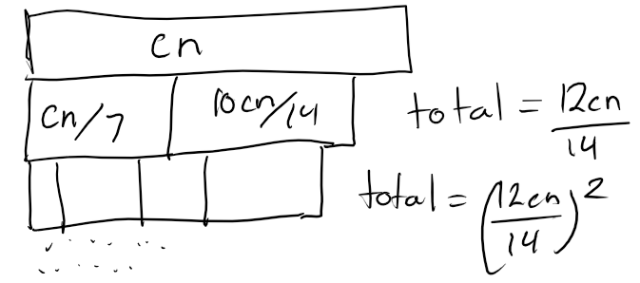

The total sum become at most

$$cn(1+\left(\frac{12}{14}\right)+{\left(\frac{12}{14}\right)}^{2}+{\left(\frac{12}{14}\right)}^{3}….)$$

* 8cn

3.

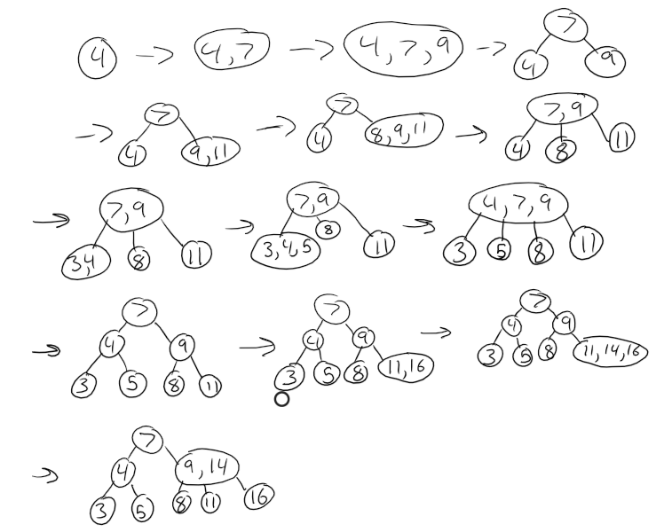

1. Basis:

If h = 1, then N(h) = 1 $≥$ ck(if c $≤\frac{1}{k}$)

If h = 2, then N(h) = 3 $≥$ ck(if c $≤\frac{1}{k^{3}}$)

A relaxed AVL tree of height h has a subtree of height h-1 and a subtree of size h-3 so you get

$$N\left(h\right)=1+N\left(h-1\right)+N(h-3)$$

Induction Hypothesis:

N(h) $≥ck^{h}$ for all h > 2

Induction step:

$$N\left(h\right)=1+N\left(h-1\right)+N\left(h-3\right)$$

$$≥1+ck^{h-1}+ck^{h-3}$$

$1+ck^{h-1}+ck^{h-3}≥ck^{h}$

$ck^{h-1}+ck^{h-3}≥ck^{h}$

$\frac{ck^{h-1}+ck^{h-3}≥ck^{h}}{ck^{h-3}}$

$k^{2}+1≥k^{3} if k^{2}-k-1=0$

Therefore, we have proven that $N\left(h\right)≥ck^{h}$